 | first Name | last name | e-mail address | address | telephone number | country
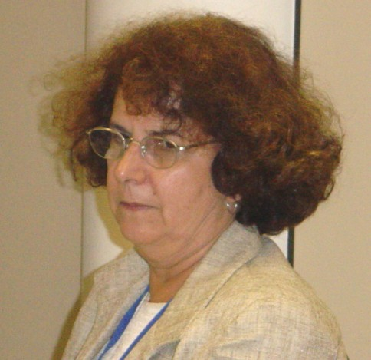 | Claudia | Travassos | claudia@cict.fiocruz.br | FIOCRUZ  Avenida Brasil, 4365  Pavilhão Haity Moussatché  21045-900 - Rio de Janeiro - RJ | (55 21) 3865.3244 | Brazil
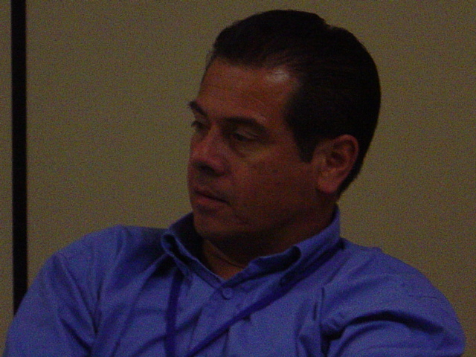 | Carlos | Zamora | czamora@ccss.sa.cr  cazamora@racsa.co.cr | PO Box 47 – 2100  San Jose – Costa Rica | (506) 295.2553  (506) 271.2539 | Costa Rica
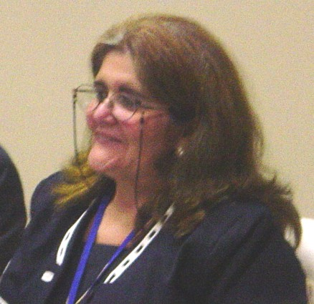 | Caridad Teresita | Garcia-Alvarez | caritere@infomed.sld.cu,  psicoine@infomed.sld.cu | Calle Calzada # 253  e/J – I. altos  Vedado – Ciudad habana 10400 – Cuba | (537) 832.0001  (537) 832.3545 | Cuba
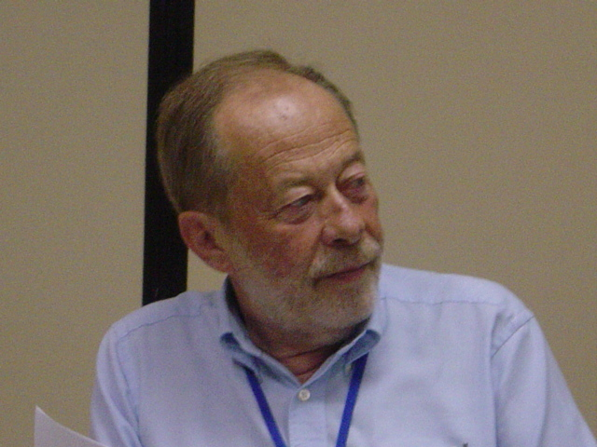 | Norberto | Dachs | dachs@ime.unicamp.br | Depto de Estadística – UNICAMP  CP 6065  13100 – Campinas – SP | (55 19) 3295.5540  (55 19) 3788.6065 | Brazil
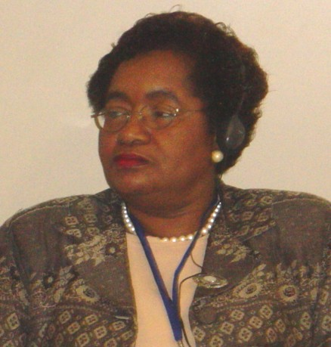 | Eva | Lewis-Fuller | fullere@moh.gov.jm | Ministry of Health  Oceana Biulding  2 – 4 King Street  Kingston – Jamaica | (876) 977.2144 (h)  (876) 967.3538 (w) / 967.1100(w) | Jamaica
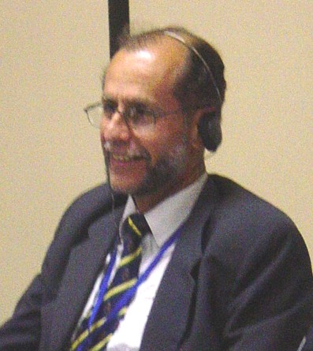 | Carlos | Agudelo | caagudeloc@unal.edu.co | Instituto de Salud Publica  Fac. Medicina  OF318 Universidad Nacional de Colombia – Bogota | (571) 316.5405 | Colombia
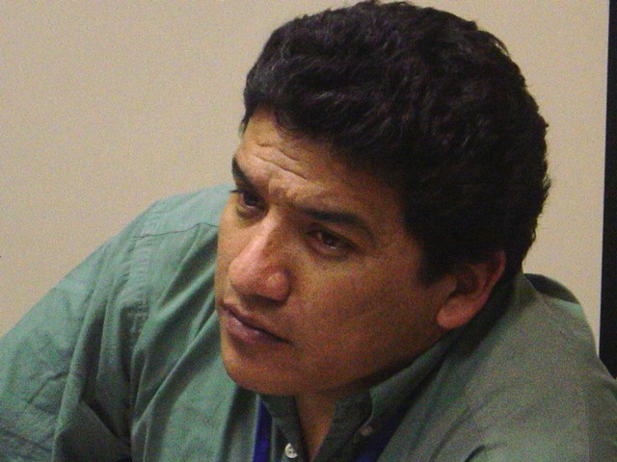 | Walter | Flores | wflores@worldwidedialup.net | Asesor en temas de Equidad  Ciudad Guatemala | (502) 479.4824 | Guatemala
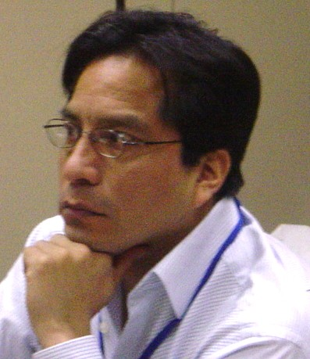 | José Martín | Valdivia | jvaldivi@grade.org.pe | Investigador Principal, Grade Coordinator, Alianza para la Equidad en Salud en Peru (AES)  Av. Del Ejército 1870  Lima – Peru | (511) 264.1780 | Peru
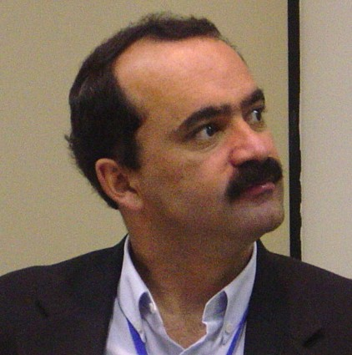 | Ricardo | Batista | ribatista@yahoo.com | Epidemologo investigador, Responsible Nacional de Medicina Preventiva, Caja de Salud de Banca Privada, Bolivia  Av. 6 de agosto Edif.. Hilda 1801, La Paz | (591-2) 244.4045  239.2395 int. 210 | Bolivia
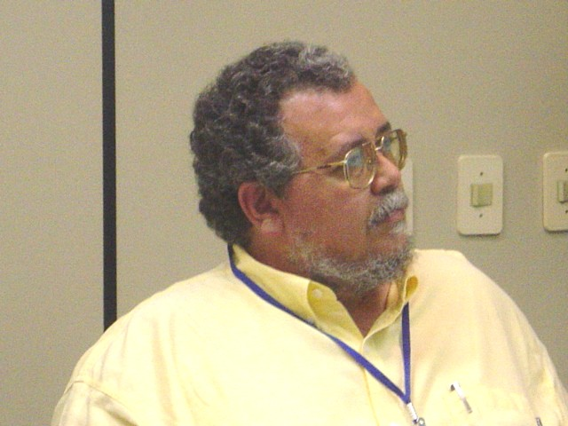 | Guillermo | Gonzalez | ggonzal@udgserv.cencar.udg.mx  ggonzal@cencar.udg.mx | Director, Centro de Estudiios en Salud Población y Desarrolo, Universidad de Guadajara, Mexico  Sierra Mojada 950 Edif O 1er piso  CP 44340 | (52 33) 3654.1836  (52 33) 3641.1119 | Mexico
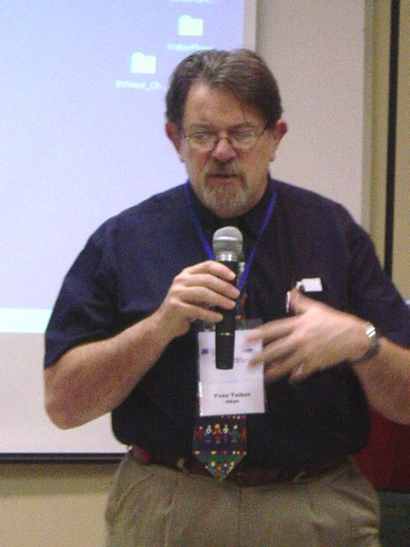 | Yves | Talbot | family@ican.net | Professor and Director – International Programs  Faculty of Medicine – University of Toronto  256 McCaul Street, Third Floor, suite 308  Toronto – ON – M5T 1W5 | (416) 978.3763  (416) 978.3912 | Canada
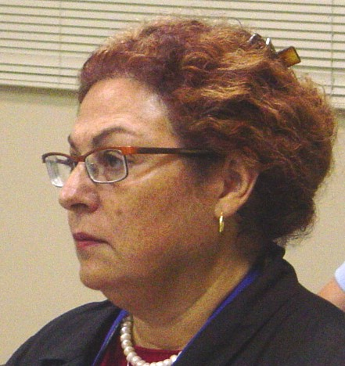 | Monica | Riutort | monica.riutort@utoronto.ca | Executive Director ISEqH  256 McCaul Street, Third Floor, suite 308  Toronto – ON – M5T 1W5 | (416) 978.3763  (416) 978.3912 | Canada
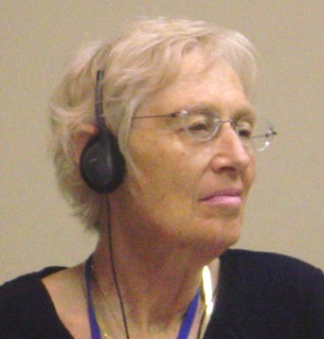 | Barbara | Starfield | bstarfie@jhsph.edu | 624 N. Broadway, km 452  Baltmore MD 21205 - USA | (440) 955.3737  Fax: (410) 614.9046 | US
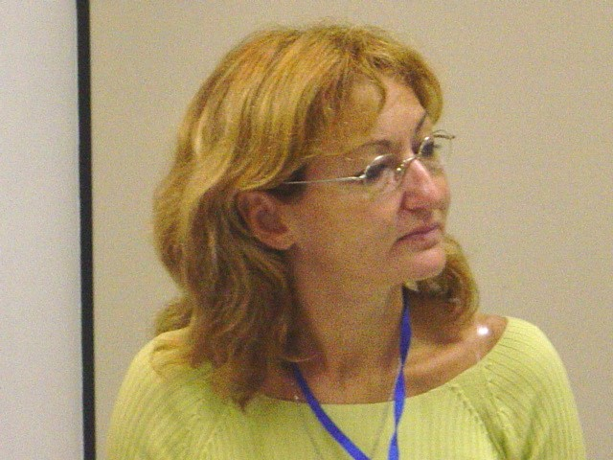 | Debora | Tajer | dtajer@psi.uba.ar | Southern Cone Coordinator  Alames  Av. Chenaut 1837, 11º A (1426)  Buenos Aires – Argentina | Telefax: (5411) 4775.2890 | Argentina
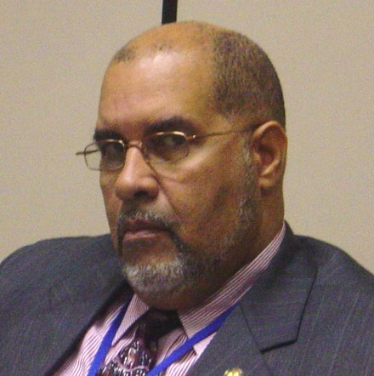 | Richard | Van West-Charles | vanwestr@paho.org | Area Manager  Information Knoledge Managment  Focal point – Equity |  | US
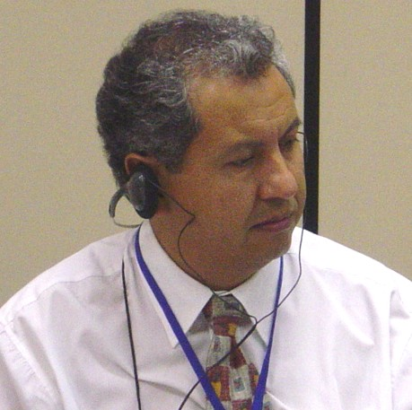 | Alfredo | Calvo | acalvo@bol.ops-oms.org | Calle Campos esquina 6 de agosto, Edifício “El Cipres” departamento 6-A | (591 2) 241.2465  (591 2) 214.1173 | Bolivia
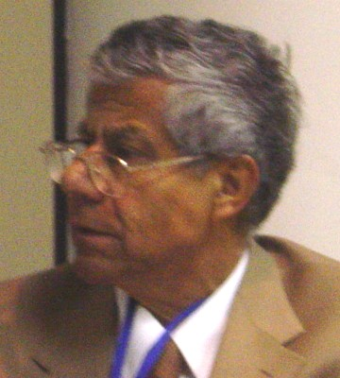 | Carlos | Montoya-Aguilar | cmontoya@minsal.cl | Departamento de Estudios  Ministerio de la Salud  Maclever 541, Santiago, Chile | 56 (2) 630.0370 | Chile
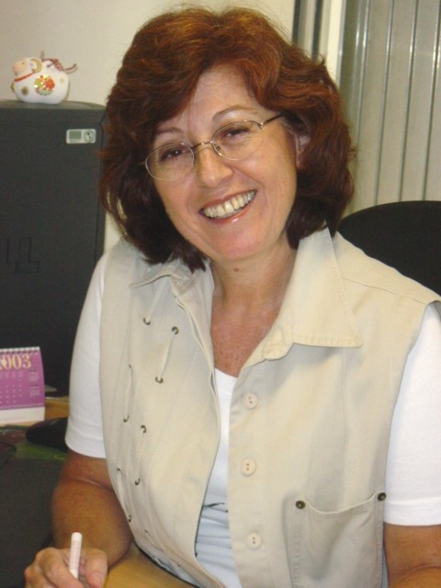 | Elenice | De Castro | castroel@bireme.ops-oms.org | BIREME/ OPAS/ OMS  Coordenadora EVE/ GA  Rua Botucatu, 862 – Vila Clementino  04023-901 – São Paulo – SP – Brasil | (55) 11-5576.9811 | Brasil

